Projection

I2C Native to OpenPLC

# UX

## New device

* Create a new map with the (+), the can be change the driver file.
* 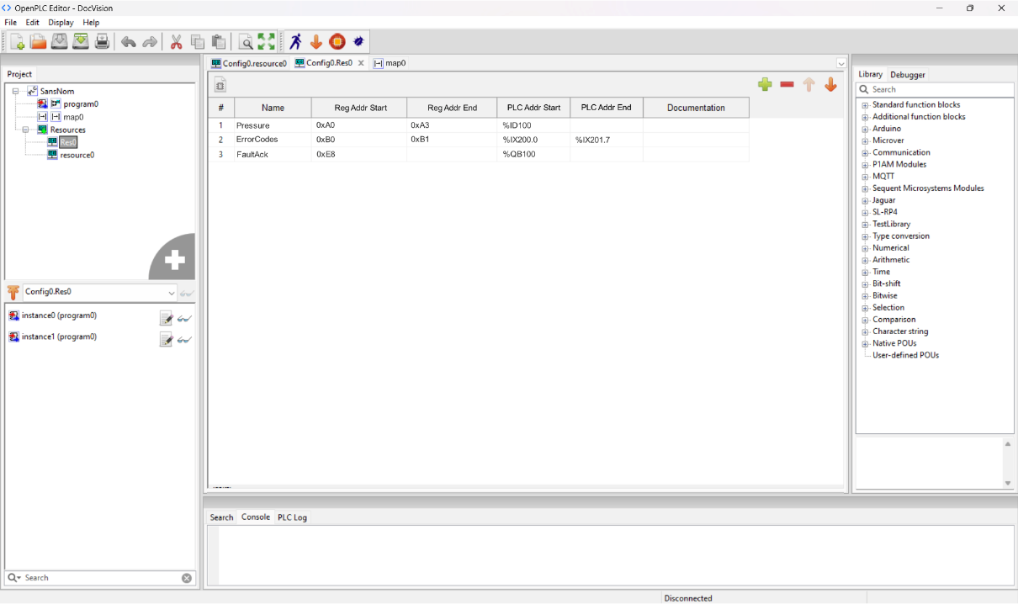Assign the registers addresses of the device to the PLC addresses
* 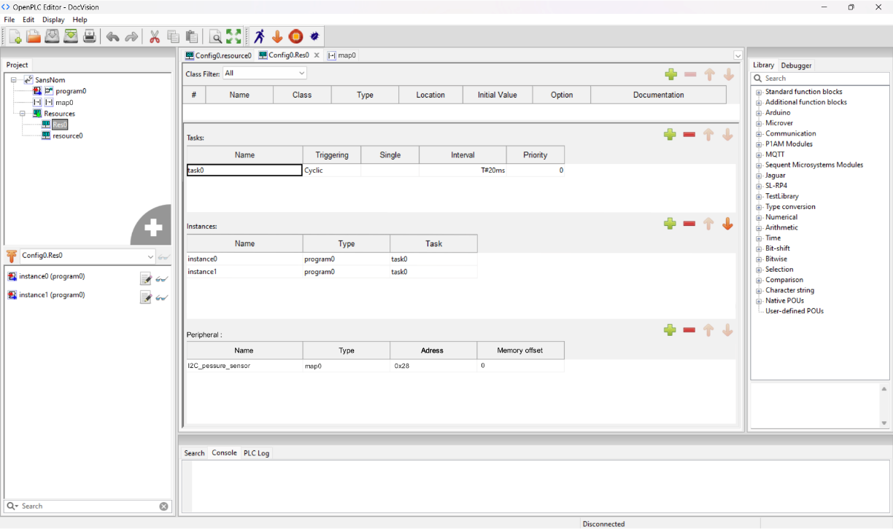Add the map to the resources in the peripheral section with the I2C device address. If there is multiple device with the same map, make sure to add a sufficient memory offset for the PLC address, to avoid conflict. This value is in byte.

# Driver

## Description

The driver will be a Arduino (C) with a necessary function (ReadWrite) which will be the interface between the I2C device and OpenPLC address. The argument and a comment above the definition will be use in the UI to create the table columns.

(work in progress)

# Implementation